REPORT ON CAREER COUNSELLING SESSION
Date: 17 July 2021
VENUE: GOOGLE MEET
Attended by: Class XI (COMMERCE & ARTS)
Organised by: Deepalaya School Kalkaji Ext.

A Career Counseling Session was conducted by Deepalaya School for the XI class to clear their doubts about the professional courses after XII and entrance exam that they have to face during the process of getting into the university. This session was attended by 65 students.

MR. ASHISH from TIME Institute , a senior Manager Marketing was speaker for the session. The session begins by asking the students regarding where they want to take admission after their class 12th ,to which most of the students responded Delhi University. A power point presentation regarding the same was also shown by Mr. Ashish, who had an experience of taking career counseling session at more than 100 schools. Speaker briefs the students about different options available in Delhi University. He also explained about the competition they are going to face for getting admission in DU. It is common among students going through this transition phase to get influenced by misinformation and end up making wrong decision. Students were made aware of the different options in profession and courses they could pursue based on the subject choices they would make
The session also made students aware with the fact that they need to be ready with different plans like if getting admission in DU is their priority ,i.e Plan A then they should be ready with his/her Plan B in case he / she is unable to get admission in DU. Plan B should include other good courses like mass communication, journalism, professional courses like BMS/BBA, BFIA, BBE, IPM, LAW, CLAT, JOURNALISM, Hotel Management, ,mass communication, BCA etc which are offered by DU as well as by other universities.
The session made the students aware about the entrance exam which conducted to check the aptitude of student to get admission for undergraduate management programmes at Delhi University’s affiliated institutions.
Overall the session was very helpful, productive. It gives many students an idea so that they can choose right career option for them in the future. We look forward to have such sessions in the future as well. 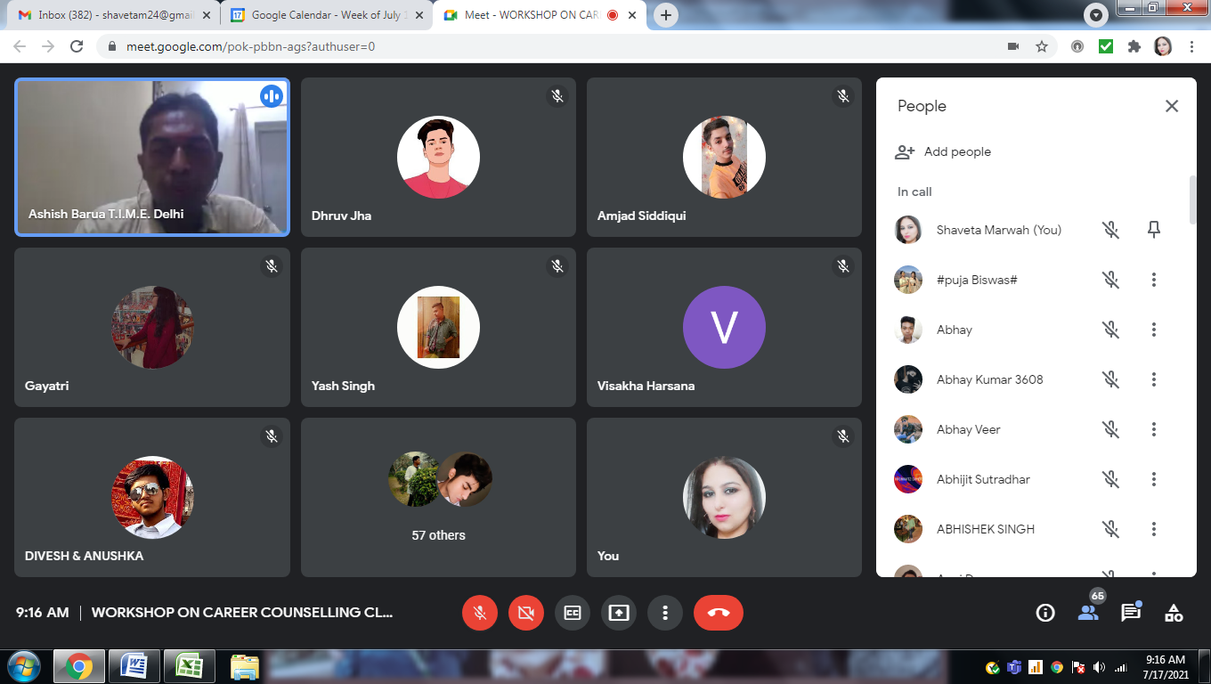
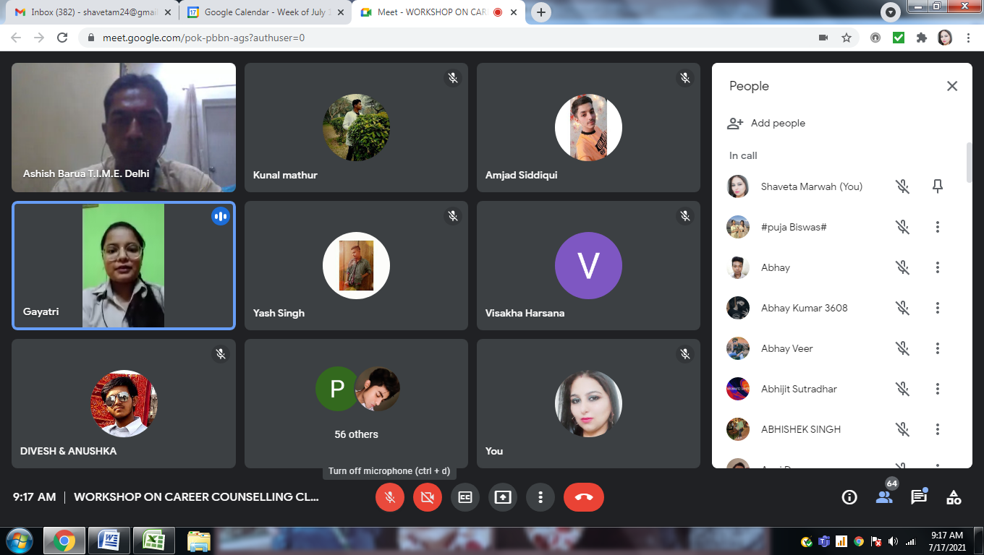

REPORT ON CAREER COUNSELLING SESSION
Date: 17 July 2021
VENUE: GOOGLE MEET
Attended by: Class XII (COMMERCE & ARTS)
Organised by: Deepalaya School Kalkaji Ext.

A Career Counseling Session was conducted by Deepalaya School for the XII class to clear their doubts about the professional courses after XII and entrance exam that they have to face during the process of getting into the university. This session was attended by 68 students.

MR. AMIT PODDAR from TIME Institute , a senior Regional Head was speaker for the session. The session begins by asking the students regarding where they want to take admission after their class 12th, to which most of the students responded Delhi University. A power point presentation regarding the same was also shown by Mr. AMIT, who had an experience of taking career counselling session for more than 16 years. Speaker briefs the students about different options available in Delhi University. He also explained about the competition they are going to face for getting admission in DU. It is common among students going through this transition phase to get influenced by misinformation and end up making wrong decision. Students were made aware of the different options in profession and courses they could pursue based on the subject choices they would make
The session also made students aware with the fact that they need to be ready with different plans like if getting admission in DU is their priority ,i.e. Plan A then they should be ready with his/her Plan B in case he / she is unable to get admission in DU. Plan B should include other good courses like mass communication, journalism, professional courses like BMS/BBA, BFIA, BBE, IPM, LAW, CLAT, JOURNALISM, Hotel Management, ,mass communication, BCA etc which are offered by DU as well as by other universities.
The session also made the students aware about the entrance exam which conducted to check the aptitude of student to get admission for undergraduate management programmes at Delhi University’s affiliated institutions.

The session also made students aware about some tricks and concepts of vocabulary building and vedic maths so as to solve a question quickly.
Overall the session was very helpful, productive. It gives many students an idea so that they can choose right career option for them in the future. We look forward to have such sessions in the future as well.
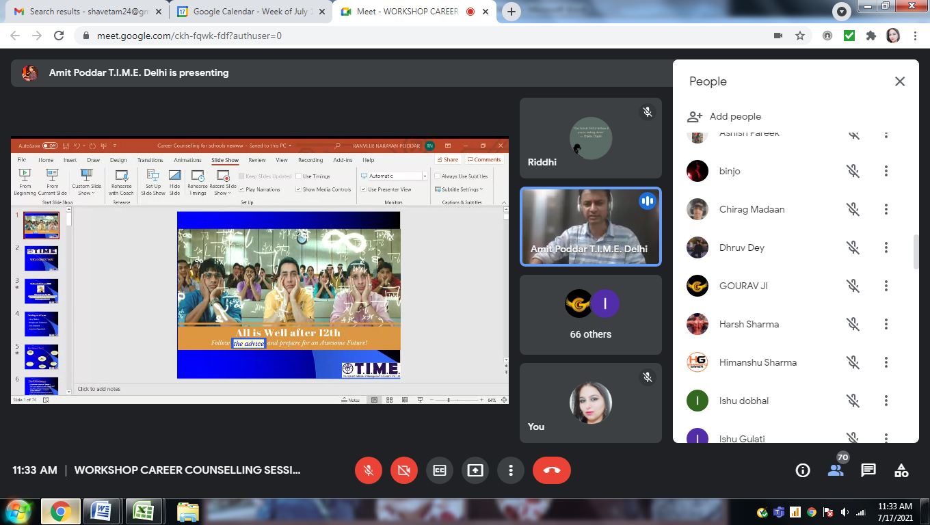

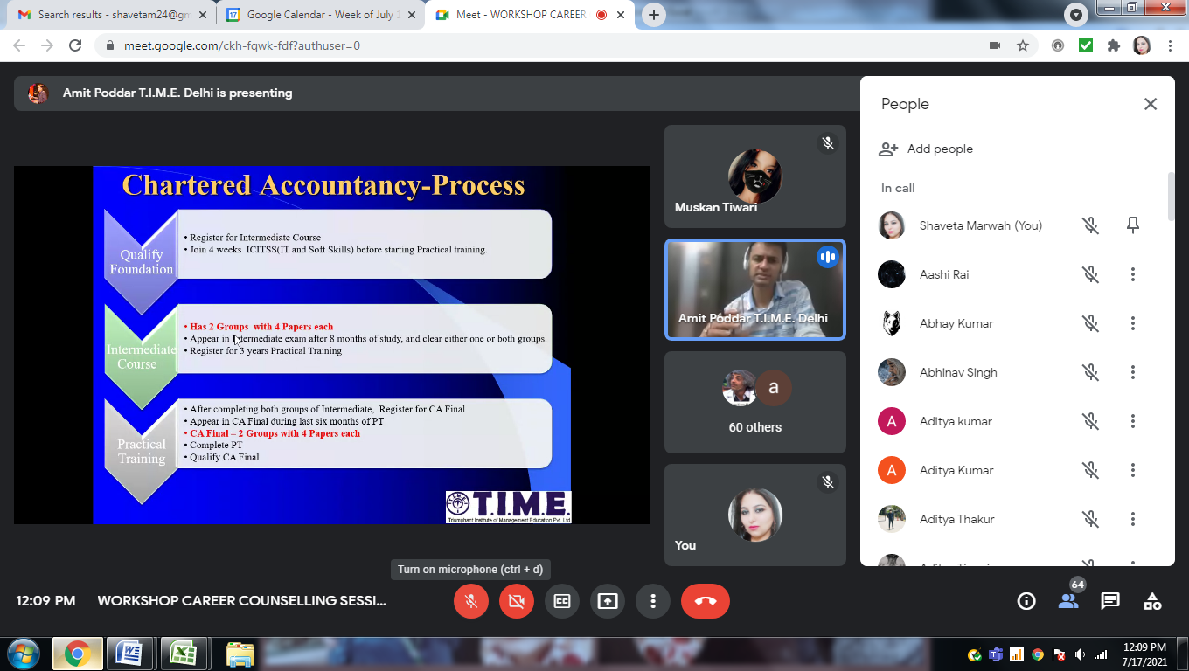

NCC
NCC theory classes are going on every Wednesday*
Duration 1 hour (Time 1pm to 2pm)
Cadets Strength – 35 to 55
Platform – Google meet
Below mentioned topic has been covered.
Arms objectives and org of NCC (Taken by Ano Shailender Bhandari)
Incentives of cadets (Taken by Ano Shailender Bhandari)
Duties of NCC cadets (Taken by Ano Shailender Bhandari)
Responsibility of NCC cadets (Taken by Ano Shailender Bhandari)
0.22 Riffle (Taken by Army unit staff Sir Abhinit Singh)
Convictional Sign (Taken by Army unit staff Sir Abhinit Singh and Awadh Bihari)
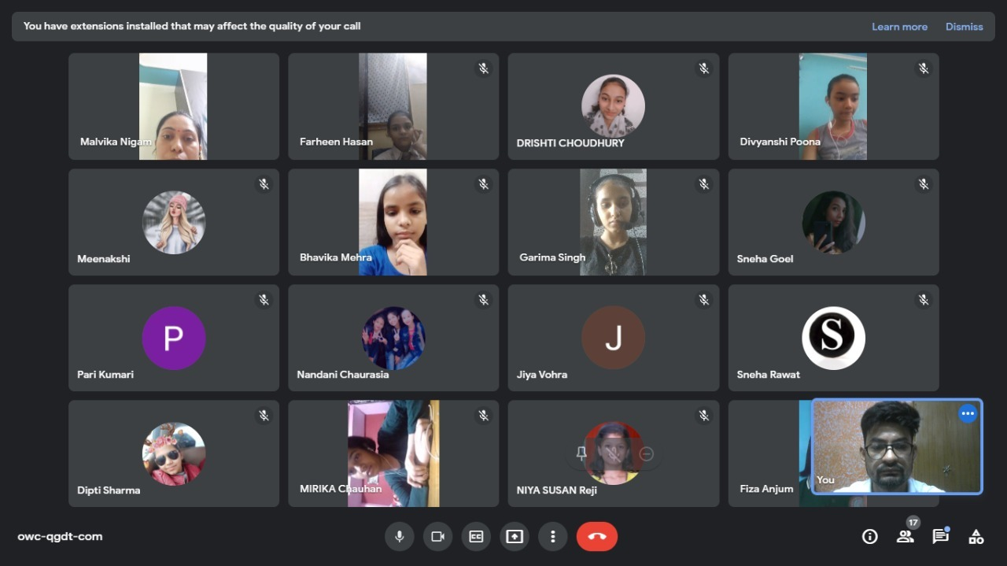

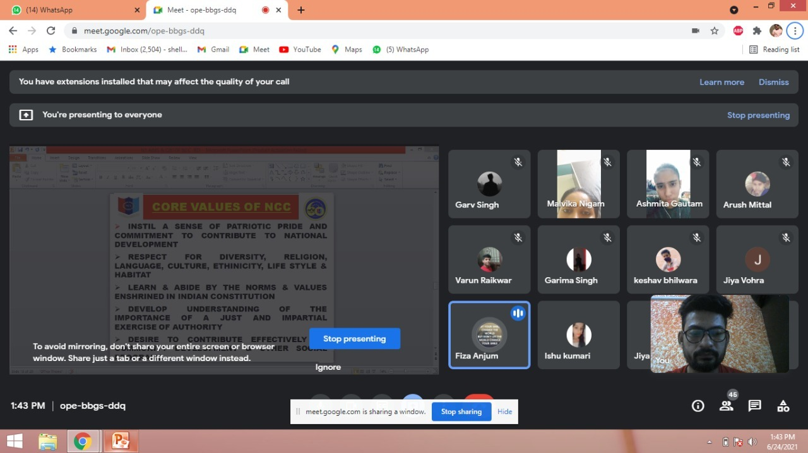
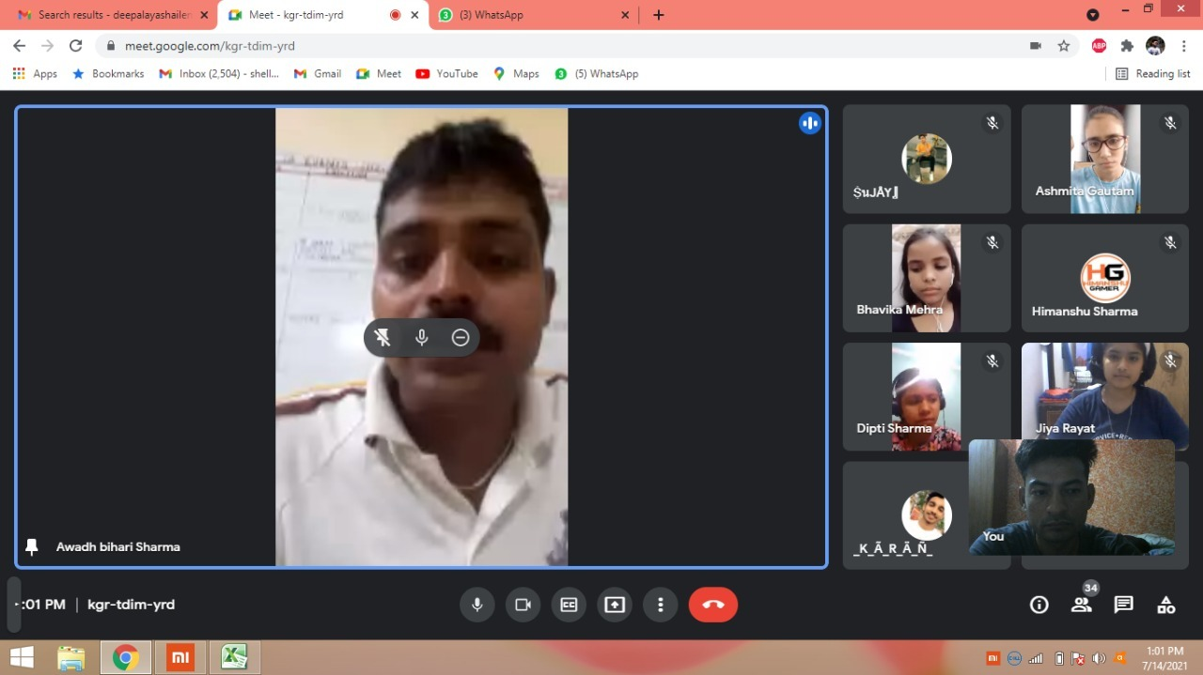
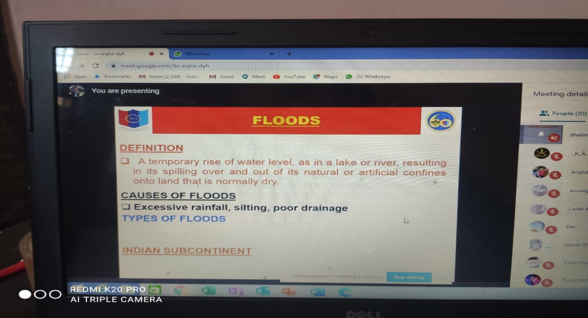

TEACHER’S DAY CELEBRATION
The Teacher's Day celebration was organized by DSSSKE (Deepalaya Senior Secondary School Kalkaji Extension) in the school auditorium on 3.9 2021. It was a joint celebration by DSSSKE and DSSSG(Deepalaya Senior Secondary School Gusbethi).Teachers from Gusbethi school were our guests for the day.We had the pleasure of having amongst us Rev.Fr.Shiju, Principal DSSSG, Mr.T.M.Abraham, chairman, Dr.George John, CEO, Deepalaya, Mr.A.J.Philip, Manager, DSSSKE and Mrs.Betty Philip, our Principal Shaju .P.P.
Both the schools sang songs on the occasion.
Wonderful thoughts were delivered by Rev.Fr.Shiju, Dr.George John and A.J.Philip.
The programme winded with the National Anthem.
The cherry on the cake was a sumptuous lunch served at school.
Slogan writing for “Healthy Air Healthy Planet “
A slogan writing drive is organised at school to emphasise the importance of clean air in our life. Due to COVID protocol not many students could attend the drive but they are shown PPT on air pollution and preventative measures to reduce air pollution.

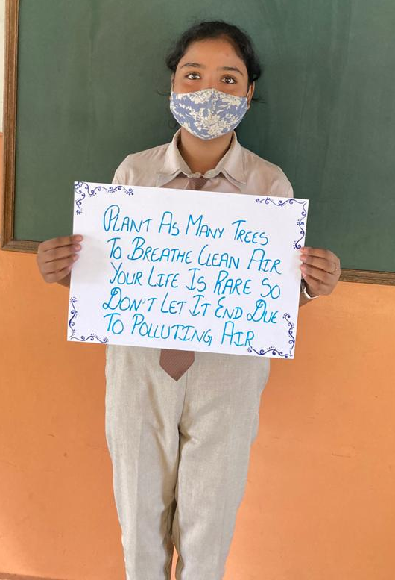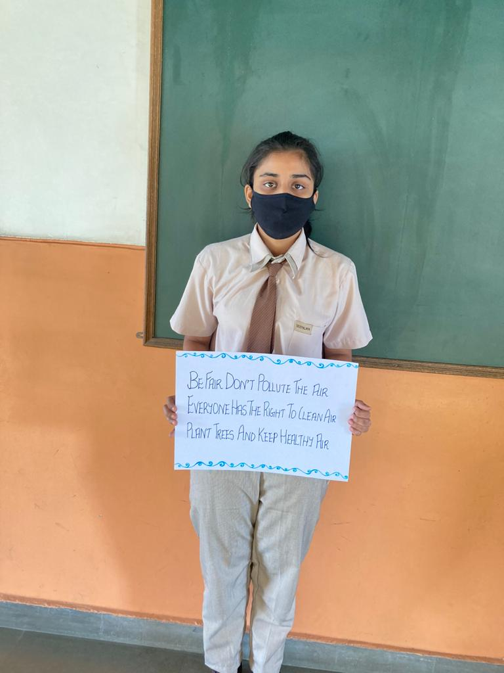
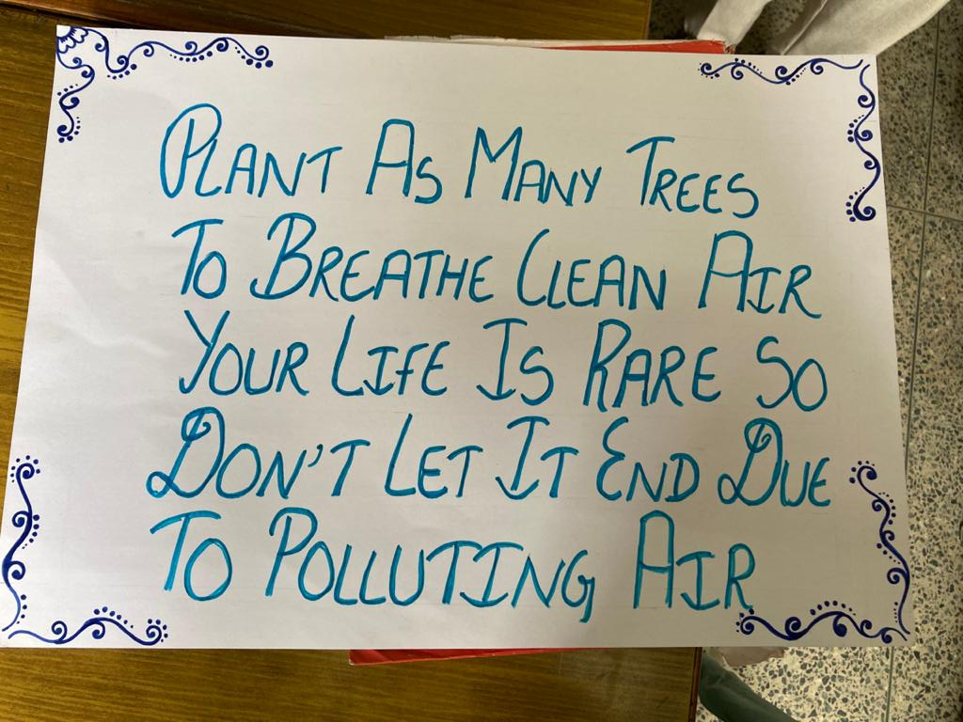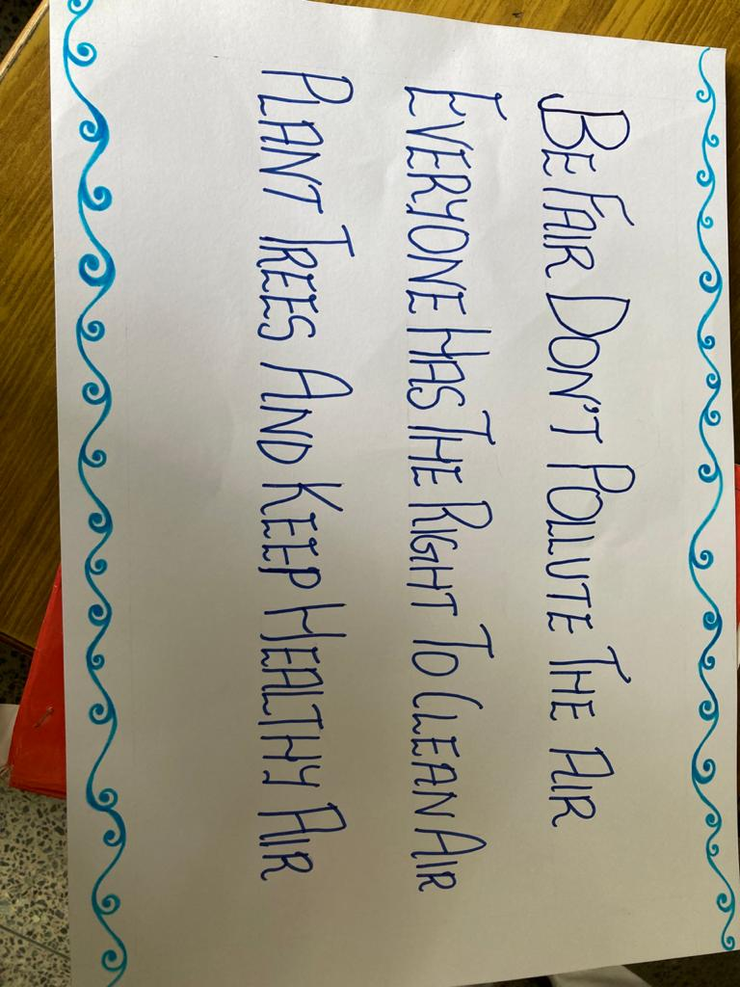

REPORT ON WEBINAR: “FINANCIAL LITERARY AND AWARENESS”
Date:8th January,2022
Venue : Google meet
Timing : 11 am – 12 noon
Attended by: XI,XII Commerce

Session was conducted by ICICI foundation for the Commerce students of Deepalaya School, Kalkaji Extension. It was a very helpful workshop for all the students as we get to know about the Banking, Deposits, Loans, Insurance, etc. The speaker of the webinar was Mr. RAJU V DAMODARAN, who is a Fin Edu Counsellor from ICICI foundation from Cochin,
a holder of Masters Degree in Bank Management and CAIIB, also possess Cert. for GST Practitioner issued by (Dept of MSME GOI).Session begins by elaborating students on the following topics:
1) Financial Literacy and its features
2) Banking: It is basically accepting funds from public and lending it to others in a way of loan.
3) Types of banks accounts
•Savings A/C
•Current A/C
•Fixed Deposit A/C
•Recurring Deposit A/C
A brief explanation on types of bank accounts, their rate of interest, and about their features.
4) Modes of Remittances
NEFT: National Electronic Funds Transfer
RTGS: Real Time Gross Settlement
UPI: Unified Payment Interface
IMPS: Immediate Payment Service
5) KYC: Know your Customer: It is document issued by the govt. of India and a very important for opening bank accounts.
6) Plastic Money: Debit and Credit Cards our plastic money
7) Education Loan: which is very helpful for education of a child.
8) Insurance: Insurance helps us from presence of risk
Few highlights about Bills and receipts, Govt. Sponsor Schemes, Foreign Exchange etc.
Last but not the least and Awareness and Prevention of Frauds and measure to prevent the frauds were also explained well.

Overall the workshop was very much helpful, productive. It gave an idea about Financial Literacy to every child. We are further looking forward to have more sessions/workshops like this.
Images are below: